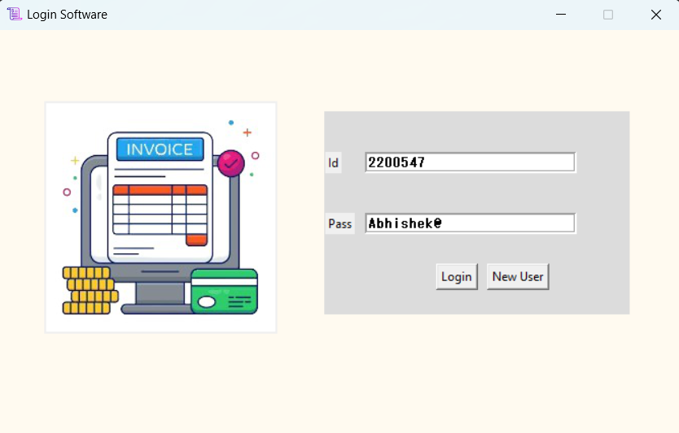

**Fig**. Login Page , Enter the Id and pass for Successful login and press login button.

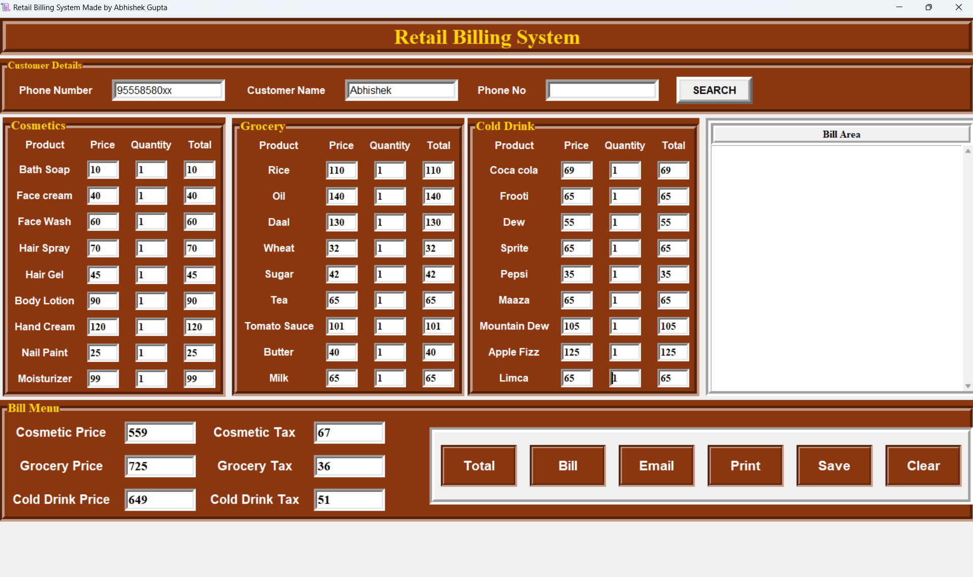

**Fig**. After Successful Login Main Page .

Enter the Customer Detail and Quantity of product to generate PRICE using Total Button.

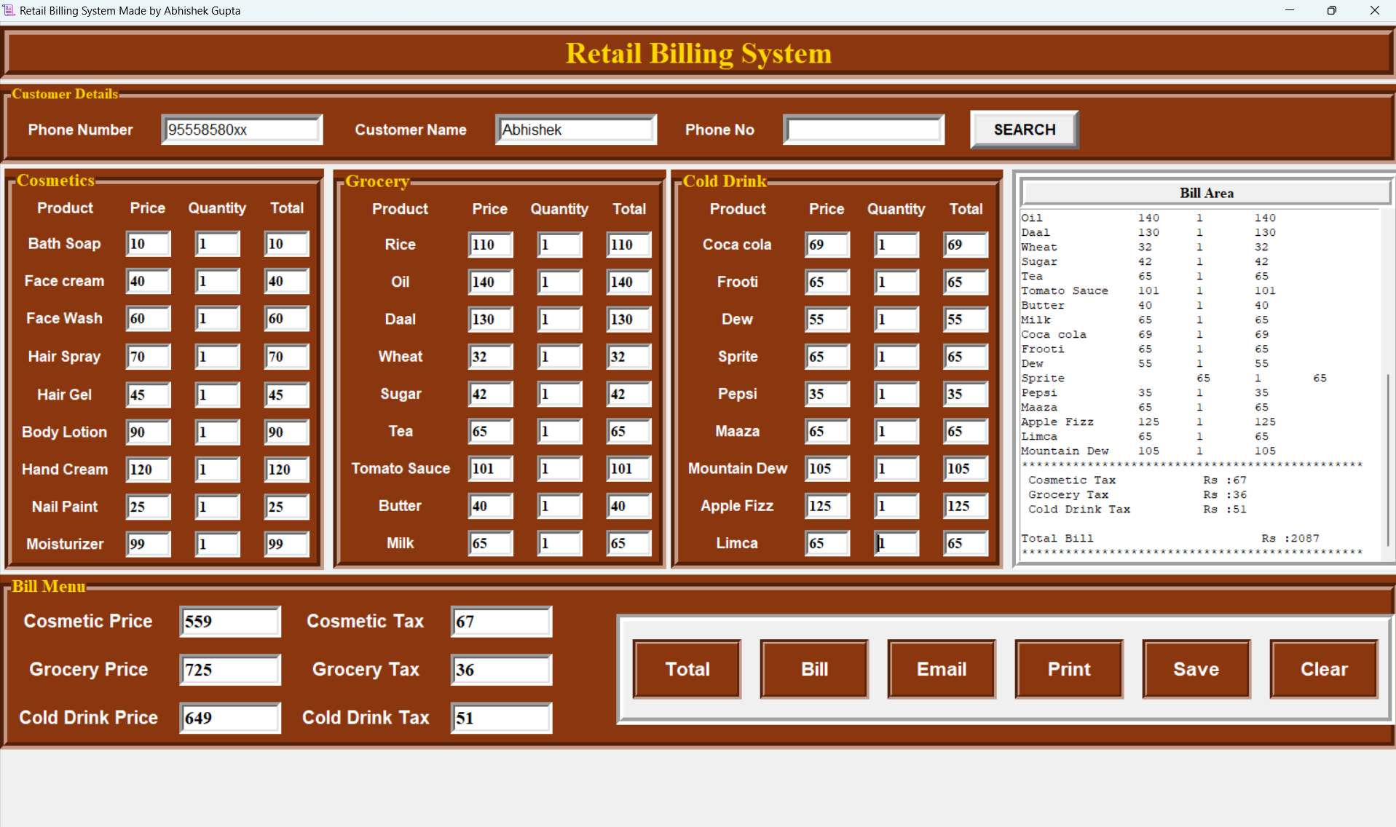

**Fig.** Generating the bill from press Bill Button.

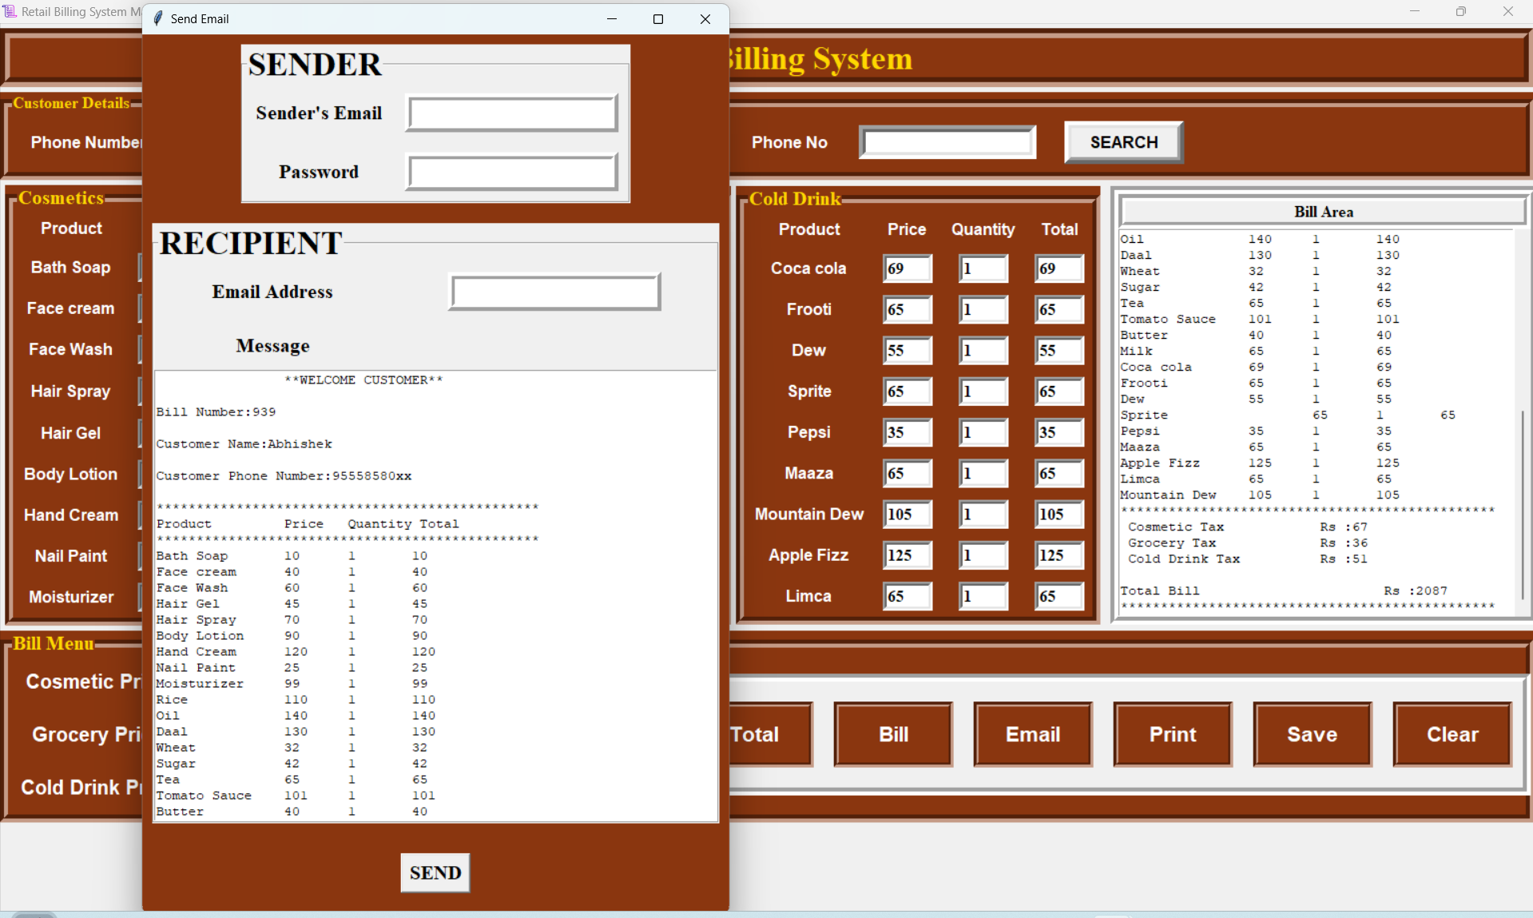

**Fig.** Sending the email of bill through Email Button.

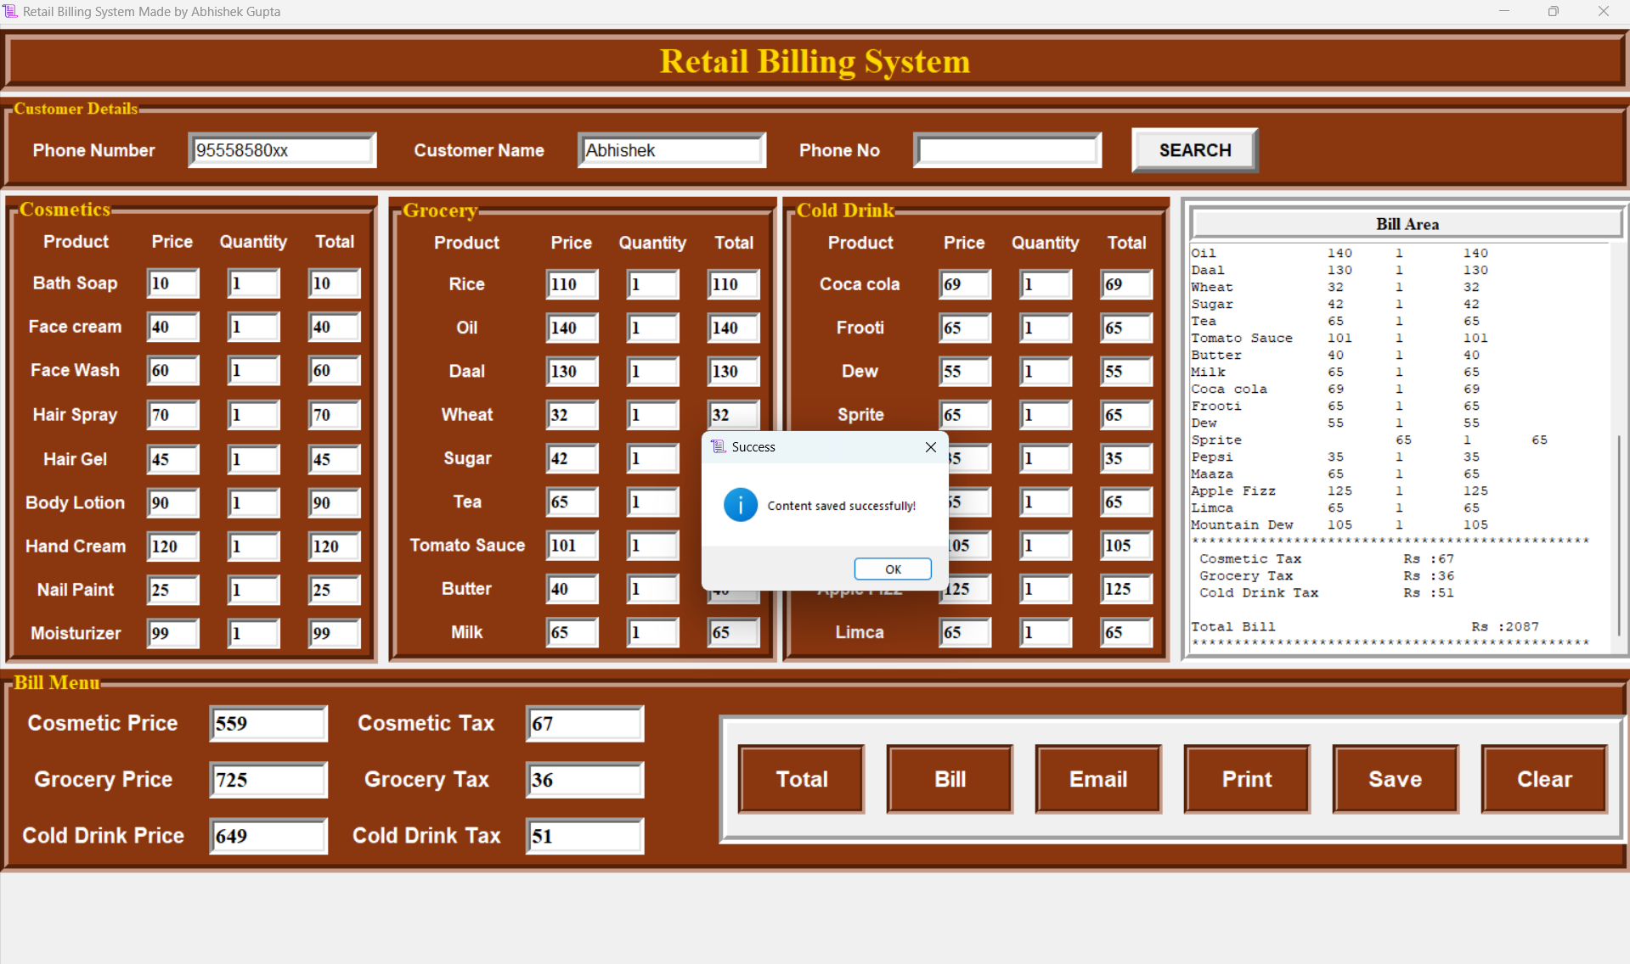

**Fig**. For printing press print Button and for save press the save button and then ok.

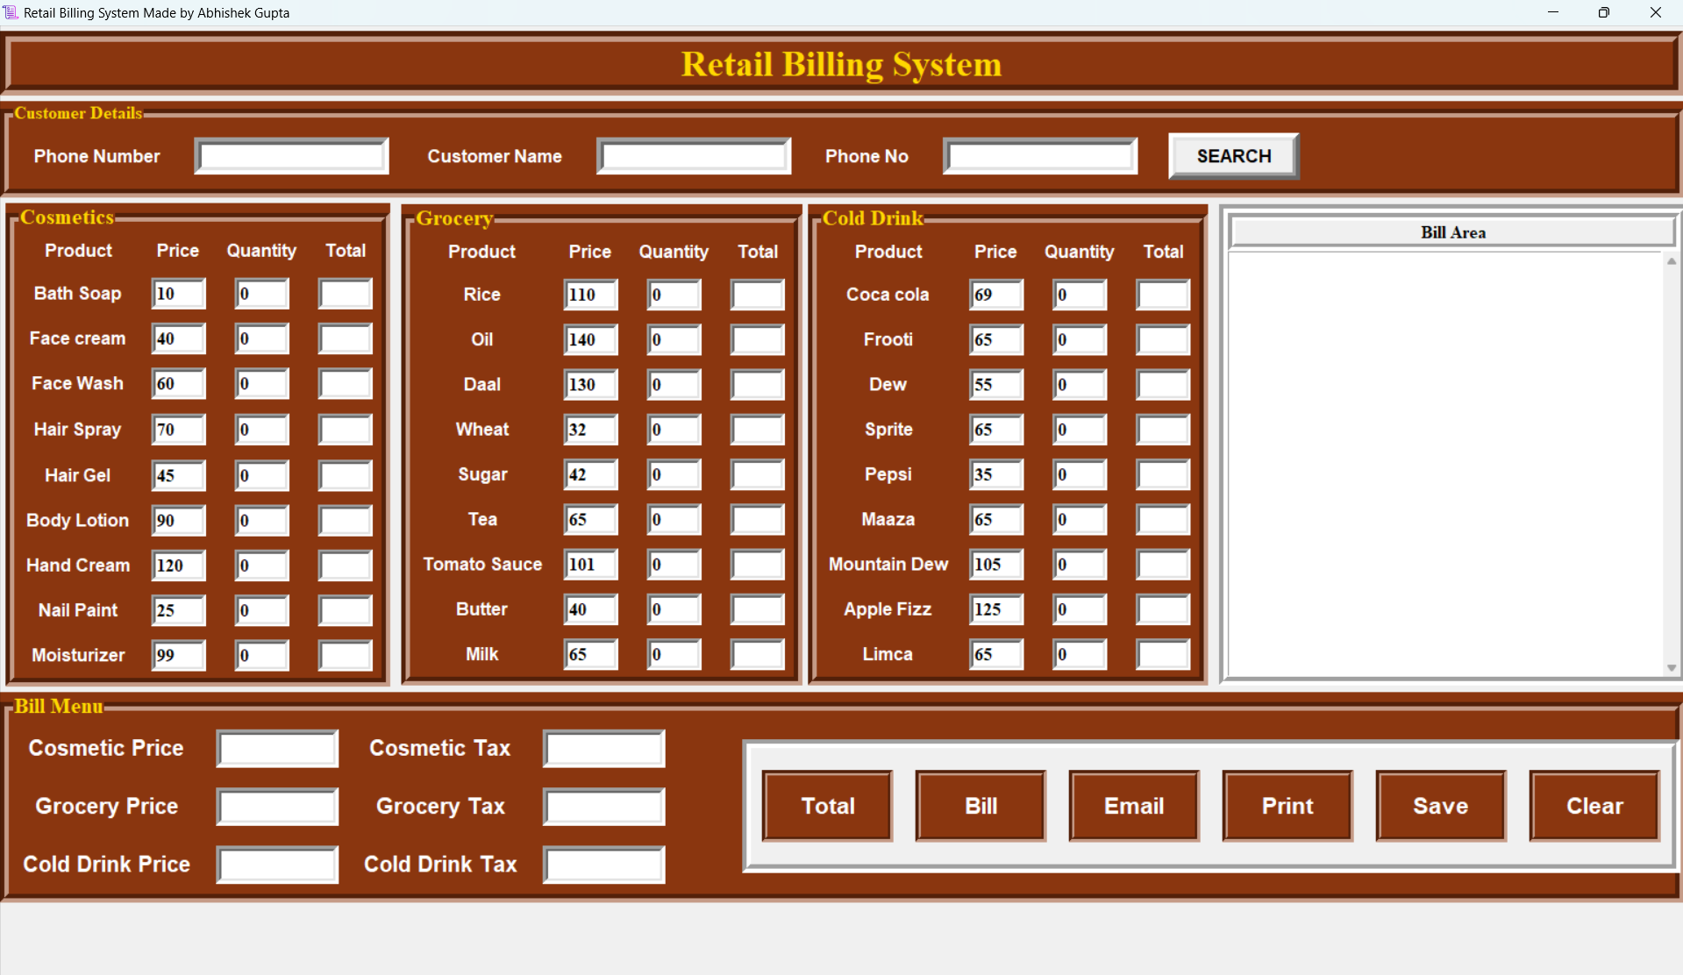

**Fig** . Enter Clear Button to delete all the entry box in main page.